**36th annual**

**REGISTRATION ASSISTANCE MARCH 8, 2023 FROM 10am-Noon AT FORT BENJAMIN PARK**

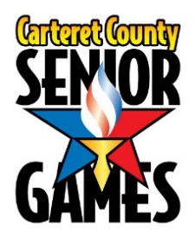

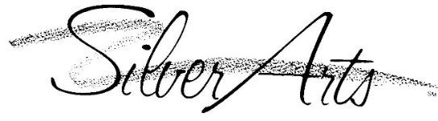**AND**

**Official Entry Form**

**March 20, 2023 – April 25, 2023**

**Early Bird Registration Dates: January 17-March 3 Fee**= $15

**Final Registration Dates: March 4-March 10 Fee**= $20

**\*\* Coordinating Agencies and Local Sponsors\*\***

**County of Carteret**

**Carteret County Parks & Recreation**

**Carteret County Health Department**

**Carteret Health Care**

**Morehead City Recreation Center**

**Brandywine Bay Golf Club**

**Cape Carteret Aquatic & Wellness Center**

**Leon Mann Jr. Enrichment Center**

**Local Government Federal Credit Union**

**MacDaddy’s Bowling Center**

**West Carteret High School**

**Crystal Coast Civic Center**

**Humana**

**Bobby Watson’s Carteret County Speedway**

***Carteret County Senior Games Mission Statement***

***“To promote healthy living and active lifestyles with community participation by setting and achieving goals in sports and arts competitions.”***

Carteret County Senior Games Official Entry Form General Information

**ELIGIBILITY A participant must be a North Carolina resident for a minimum of three (3) consecutive months of the calendar year.** A person must be 50 years of age or better to participate. Participants will compete against others of their own age and sex as follows: 50-54, 55-59, 60-64, 65-69, 70-74, 75-79, 80-84, 85-89, 90-94, 95-99, and 100+. In doubles sports, the age of the youngest player determines the age group for competition.

**RULES** **Carteret County Senior Games are open games**. Any schedule changes must be made by March 10, 2023, with the exception of **PICKLEBALL played on 3/28-3/29. If you are entering doubles/mixed doubles, your entry in that event will not be complete until your partners form has be received.**

**No partners will be assigned at events.**

All events will be conducted in accordance with the 2023 Edition of the North Carolina Senior Games Inc. Official Rules and SilverArts Booklet both of which are located on the website at **www.ncseniorgames.org**

**WHAT DO I RECEIVE?** Registration fee includes a participant t-shirt, participation in Athletic and/or Artistic Events and free admission to the following Events: SilverArts Exhibit at Fort Benjamin Park, Opening Ceremonies, and Awards/Lunch.

**AWARDS** All medals will be awarded April 25, 2023. One gold, silver or bronze will be awarded to represent all events placed in, along with a documented list of all events placed in. All sports medalists qualify to participate in the North Carolina Senior Games State Finals, SEPTEMBER, 2023. Exceptions: ONLY First-Place Medal Winners in each subcategory for Heritage and Visual Arts and First and Second-Place Literary Arts will be submitted for State competition.

**WHAT IF IT RAINS?** Unless weather has made conditions hazardous to the safety of volunteers and participants, events will continue in the rain. Participants should report to the event site and check-in, regardless of the weather. Up to date information will be available from the Event Manager in charge of each event. As an added source of updates, like our Senior Games page on Facebook. Failure to check-in will result in disqualification.

**STATE FINALS** All events offered at the local level will also be offered at the State Finals (except for those noted with an asterisk*). Participants receiving medal(s) (see above) will receive a State Finals Entry Packet upon request with a qualifying letter after the completion of the local Games. Return to North Carolina Senior Games by August 1st. Early Bird Registration deadline is July 1st. This Program is sanctioned by North Carolina Senior Games, Inc. North Carolina Senior Games is sponsored State wide by the North Carolina Division of Aging and Adult Services.

**NATIONAL GAMES** 2023 is not a qualifying year for National Games, [www.nsga.com](http://www.nsga.com).

**CYCLING** 2023 cycling event will be held at Carteret County Speedway this year. An open practice day may be scheduled prior to the event date and we will contact you by email when a date is determined.

**REFUNDS** No refunds will be granted after March 17,2023. A $5 processing fee is non-refundable.

**GOLF** To qualify for State Finals, golfers need to meet a minimum performance score (MPS) and finish in the top 3 in their age group. Additionally golfers will follow a triple bogie, pick up and go, locally. MPS is available from your coordinator and in the NCSG Rules Book at [**www.ncseniorgames.org**](http://www.ncseniorgames.org)

***“ALL EVENT TIMES AND DATES SUBJECT TO CHANGE IF NESSESARY DUE TO COVID RESTRICTIONS”***

Carteret County Senior Games Official Entry Form Participant Information

Participant Information

**FIRST NAME___________________________ MI_______________________ Last Name________________________**

**MAILING ADDRESS_________________________________________________________________________________**

**CITY____________________________________STATE____________ZIP CODE________________________________**

**TELEPHONE #________________________ DATE OF BIRTH ____/____/_____ Age as of 12/31/2023 ____**

**EMAIL ADDRESS _______________________________________________________T-SHIRT Yes__ or No__ Size___**

**please provide the above information to help us. email is our main source of contact, please provide. it will be kept confidential. thank you!**

My ethnicity: Black or African American;___ Asian;___ American Indian or Alaska Native;___ Hispanic;___ White;___ Native Hawaiian or other Pacific Islander;___ Or Unknown /Refused___.

**Medical Information**

1. Name of physician: ______________________________ Phone#: __________________________ 2. Name of medications: _____________________________________________________________ __________________________________________________________________________________ 3. Your medical conditions: ___________________________________________________________ 4. Your allergies: ____________________________________________________________________

**Emergency Contact Information**  Name: _________________________________________ Phone #: _________________________ Relationship: _______________________________________________________________________ Name: _________________________________________ Phone #: _________________________ Relationship: _______________________________________________________________________ **FEES Early Bird registration fee – received in office by Friday March 3, 2023…..…..$15.00_________ Final deadline registration fee – received March 10, 2023 …..……………………. $20.00_________ Golf – includes cart, green fees and lunch……………………………………………………$40.00_________ Bowling – 3 games WITHOUT SHOES…………………..………. # of Events _____x $10.00_________ Lunch/Awards Finale/April 25, 2023 …………………………………………………………..YES____NO_____ Luncheon Guest…………………………………………………………………………………………..$10.00_________ Mini Golf……………………………………………………………………………………………………..$6.00__________**

**Make checks payable to: Carteret County Senior Games Total Amount Enclosed=_______**

**Mail Entry forms with check/money order to: *Carteret County Senior Games 100 McQueen Avenue Newport, NC 28570* Checks should be made out to Carteret County Senior Games (CCSG)For registration assistance, please contact Carteret County Senior Games staff at Fort Benjamin Park at 252-222-5858 or ccpr.recdesk.com. Online registration available at http://torch.ncseniorgames.org**

Carteret County Senior Games Official Entry Form Athletic Events

First Name__________________________________ Last Name___________________________________ MI_____

check box to the left of your event choice

***To promote total health and physical fitness, events of longer duration and lower intensity are strongly***

***recommended. High-intensity types of activities are offered primarily for the conditioned, trained athlete.***

**Individual Sports Tournament Sports Swimming (Limit 5)**

|  |  |
| --- | --- |
|  | **Bowling** |
|  | Singles |
|  | Doubles  Name Partner: |
|  | Mixed Doubles  Name Partner: |
|  | **Cycling** |
|  | 1 Mile |
|  | 5 K |
|  | 10 K |
|  |  |
|  | Football Throw |
|  | Softball Throw |
|  | Golf/Handicap: |
|  | **Mini Golf NEW** |
|  |  |
|  | **Track & Field (Limit 5)** |
|  | 50 M Dash |
|  | 100 M Dash |
|  | 200 M Dash |
|  | 400 M Dash |
|  | 800 M Dash |
|  | 1500 M Dash |
|  | 1500 M Race Walk |
|  |  |
|  |  |
|  | Running Long Jump |
|  | Shot Put |
|  | Standing Long Jump |
|  | Silverstriders Fun Walk |
|  |  |
|  |  |
|  |  |

**offered at State Finals.**

|  |  |
| --- | --- |
|  | **Pickleball** |
|  | Doubles  Name Partner: |
|  | Mixed Doubles  Name Partner: |
|  |  |
|  | Billiards |
|  | Bocce |
|  | Croquet |
|  | Horseshoes |
|  | Shuffleboard |
|  | **Table Tennis** |
|  | Singles |
|  | Doubles  Name Partner: |
|  | Mixed Doubles  Name Partner: |
|  | **Tennis** |
|  | Singles |
|  | Doubles  Name Partner: |
|  | Mixed Doubles  Name Partner: |
|  | Basketball Shoot |
|  | Cornhole |

|  |  |
| --- | --- |
|  | **Backstroke** |
|  | 50 Yards |
|  | 100 Yards |
|  | 200 Yards |
|  | **Breaststroke** |
|  | 50 Yards |
|  | 100 Yards |
|  | 200 Yards |
|  | **Butterfly** |
|  | 50 Yards |
|  | 100 Yards |
|  | 200 Yards |
|  | **Freestyle** |
|  | 50 Yards |
|  | 100 Yards |
|  | 200 Yards |
|  | 500 Yards |
|  | **Individual Medley** |
|  | 100 Yards |
|  | 200 Yards |
|  | 400 Yards |

**Please refer to *Schedule of Events* for dates, times and event sites.**

* **Doubles Partners – If individuals partner cannot come to State Finals, that person may select another partner who qualified in that event** **at the Local Games.**
* **Age of younger partner will determine age group**
* **Partners must be registered by March 10, 2023. No partners will be assigned at events**
* **Bowling, Mini Golf and Golf Events require an extra fee**

**Silver Arts   
(Literary ENTRIES must be returned with registration info)**

**LIMIT OF 2 ENTRIES PER SUBCATEGORY**

**Entries must be the original work of the artist and must have been completed within**

**2 years of the Local Games qualifying date.**

**HERITAGE ARTS** **VISUAL ARTS:**

____ Basket Weaving Acrylic

______Stained Glass _______Digital Art **(new in 2023)**

____ Crocheting Mixed Media

____ Pottery(Thrown and Hand built) Oil  
____ Jewelry Pastels

____ Knitting Photography (Film)

____ Needle Work Photography (Digital)

____ Quilting (Machine Stitched) Sculpture

_______Quilting (Hand stitched) ______Watercolor

____ Weaving **LITERARY: Entries must be submitted with your entry form**

____ Tole/Decorative Essay (8 pages max, double space, non biographical)

____ Wood Working Life Experience (auto biography, 8 pgs. max, double space)

Wood Carving Poem (40 lines max)

Wood Turning Short Story (8 pgs. max, double space)

______General Fiber Arts **(new in 2023)**

***LIST TITLE OF ENTRY ON LINES BELOW!***

**Please list names of all items submitted for Heritage, Visual and Literary Arts Categories:**

**1**

**2**

**3**

**4**

**PERFORMING ARTS:**

Act Name____________________________Group/Solo_____________________Number in Act_______

Music Information(Song Title)___________________Equipment Needed___________________________

Length of Act____ Act Type: Comedy/Drama___ Line Dance___ Vocal___ Instrumental___ Dance___

**CHEERLEADERS:**

Group Name _______________________________ Head Cheerleader______________________

Group Size_______ Music Title (If used) ______________________________

Act Length (Min/Sec) ________ Introductory Statement _________________________________________________________________________________

**SIGNATURE FORM**

**Liability Waiver**

I acknowledge and fully understand that I will be engaging in activities that involve risk of serious injury, including permanent disability and death, and severe social and economic losses which might result not only from their own actions, inactions or negligence, but the actions, inactions or negligence of others, the rules of play or the condition of the premises or of any equipment used. I assume all the foregoing risks, and accept personal responsibility for the damage following such injury, permanent disability or death. I release, waive, discharge and covenant not to sue the Carteret County Senior Games, its affiliated clubs, their respective administrators, directors, agents, sponsoring agencies, sponsors, advertisers and if applicable, owners and leasers of premises used to conduct the events, all of which are hereinafter referred to as “releases” from any and all liability to each of the undersigned, his or her heirs and next of kin for any and all claims, demands, losses or damages on account of injury, including death or damage to property, caused or alleged to be caused in whole or in part by the negligence of the release or otherwise. I have prepared myself for the events which I have entered by practicing prior to the Carteret County Senior Games. To the best of my knowledge and belief, I have no physical restrictions that would prohibit my participation in the events I have selected.

Carteret County Senior Games has my permission to transport me and to have a physician attend me if it is deemed necessary during my participation in local games. I agree to release and hold harmless the Carteret County Senior Games from any damage to or loss of my art entry. I certify that the art piece(s) I enter are my own work, were created after having reached age 50, and are not manufactured in any sense of the word. I grant to the Carteret County Senior Games the free and unrestricted right to use my name and picture, picture of my art work and/or written material in any broadcast, telecast or other written or photographic account to the Carteret County Senior Games without remuneration.

* **I understand it is my responsibility to read and be accountable for the information in this Official Entry Form Packet and that all information and resources for finding information pertaining to Carteret County Senior Games has been offered to me.**
* **I understand that I am to participate by the rules of Carteret County Senior Games and know that all information can be found on the Rule Changes and Reminders Page of the Official Entry Form Packet.**
* **“I understand that it is my responsibility to check with my local Senior Games Coordinator immediately following my local Senior Games to determine if I qualified for State Finals and to get a State Finals Entry Packet if I do not have internet access. My State Finals registration with payment and all required items must be received in the NCSG office in Raleigh by 11:59 p.m. on August 1st! I understand that this deadline is strictly enforced in fairness to all and it is my responsibility to make sure I am registered.”**
* ***Coronavirus / COVID-19 Warning & Disclaimer: Coronavirus, COVID-19 is an extremely contagious virus that spreads easily through person-to-person contact. Federal and state authorities recommend social distancing and wearing a face covering as a means to prevent the spread of the virus. COVID-19 can lead to severe illness, personal injury, permanent disability, and death. Participating in Carteret County Senior Games or Carteret County Parks and Recreation programs or accessing Carteret County Parks and Recreation facilities could increase the risk of contracting COVID-19. Carteret County Senior Games in no way warrants that COVID-19 infection will not occur through participation in Carteret County Senior Games programs or accessing Carteret County facilities. Organizations and users of Carteret County facilities and/or programs do so at their own risk.***

I have read the above information I have read the above information

_______________________________ ______________________________ __________

Print Name Signature Date

ADDITIONAL INFORMATION CAN BE FOUND ON NCSG WEBSITE @ http://www.ncseniorgames.org/

**See SilverArts Guidelines for general requirements**

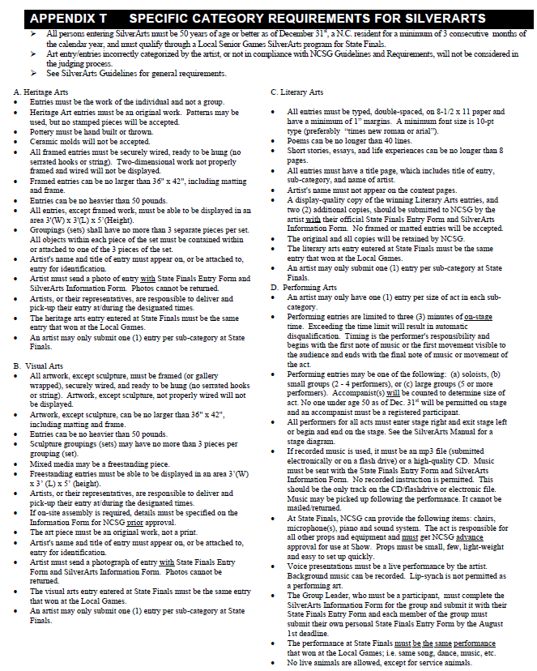

**See SilverArts Guidelines for general requirements**

|  |  |  |  |
| --- | --- | --- | --- |
| **Date** | **Time** | **Event** | **Location** |
| Monday March 20 | 11am-1pm | Opening Day/Shirt Pickup | FBP |
| Tuesday March 21 | 9am | Horseshoes | FBP |
| Tuesday March 21 | 10am | Bocce | FBP |
| Wednesday March 22 | 10am | Billiards | FBP |
| Thursday March 23 | 10am | Football Throw | FBP |
| Thursday March 23 | 11:30 am | Softball Throw | FBP |
| Friday March 24 | 9am | Basketball Shooting | MHCRC |
| Monday March 27 | 9am | Tennis | FBP |
| Monday March 27 | 10am | Table Tennis | FBP |
| Tuesday March 28 | 10am | Pickleball/DOUBLES | CIVIC |
| Wednesday March 29 | 10am | Pickleball/MIXED DOUBLES | CIVIC |
| Thursday March 30 | 10am | Bowling | MAC |
| Friday March 31 | 10am | Cornhole | FBP |
| Monday April 3 | 8am | Silverstriders Fun Walk | FBP |
| Monday April 3 | 10am-12pm | Silverarts Drop off | FBP |
| Tuesday April 4 | 9am | Cycling | CCS |
| Wednesday April 5 | 9am | Golf | BWB |
| Thursday April 6 | 9:30am | Shuffleboard | FBP |
| Thursday April 6 | 11:30am | Croquet | FBP |
| Monday April 17 | 9am | Track & Field Events | WCHS |
| Tuesday April 18 | 2:00pm | Swimming | CCAWC |
| Friday April 21 | 10am | Mini Golf | MAC |
| Tuesday April 25 | 11am-1pm | Finale/lunch/medal presentations | CIVIC |
| Friday April 28 |  | All artwork should be picked up by 4pm | FBP |

***“This program is sanctioned by North Carolina Senior Games, Inc. NCSG, Inc. is sponsored statewide by the North Carolina Division of Aging and Adult Services.”***

***“ALL EVENT TIMES AND DATES SUBJECT TO CHANGE IF NESSESARY DUE TO COVID RESTRICTIONS”***

Carteret County Senior Games 2023 Schedule of Events

BWB=Brandywine Bay Golf Club CCAWC=Cape Carteret Aquatic & Wellness MAC=MacDaddy’s Bowling Center FBP=Fort Benjamin Park

CCS=Carteret County Speedway MHCRC = Morehead City Recreation Center

CIVIC=Crystal Coast Civic Center WCHS=West Carteret High School